Operating Systems Lab Assignment – 2
Sub-Task 1: Initialize the logging configuration to capture timestamped messages.
Sol.-
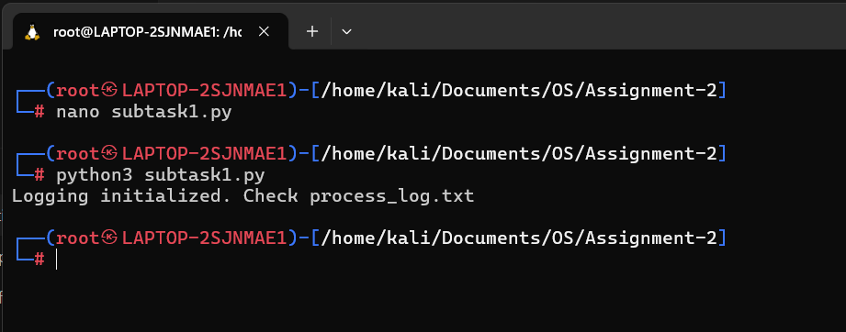
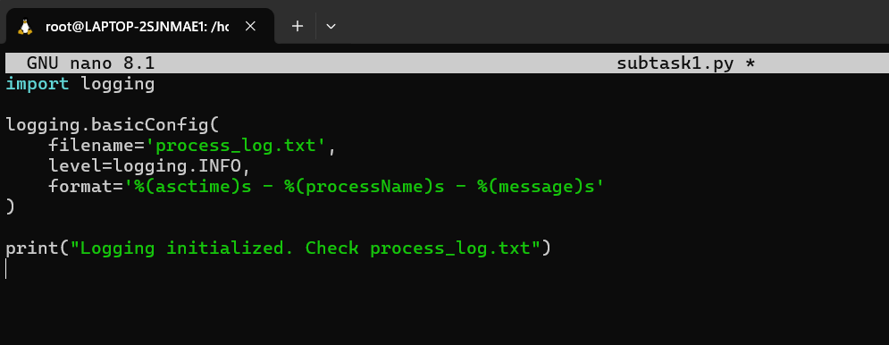
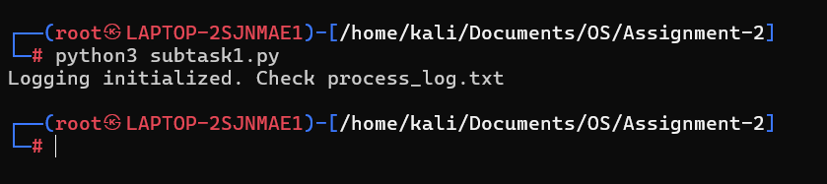

Sub-Task 2: Define a function that simulates a process task (e.g., sleep for 2 seconds).
Sol.-
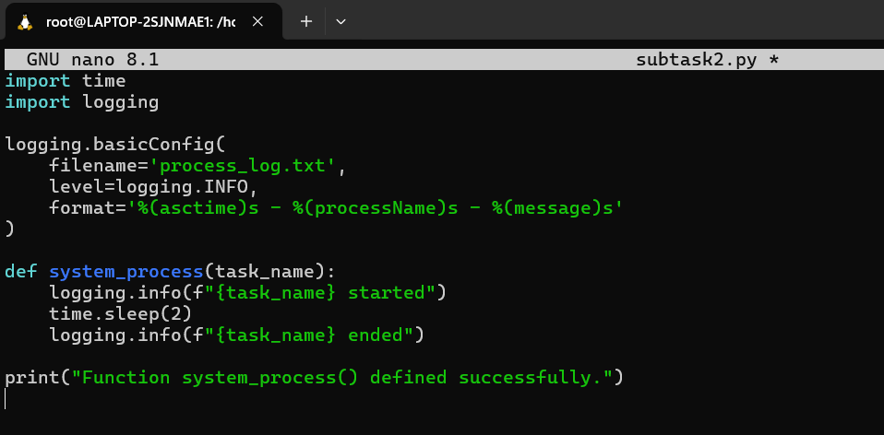
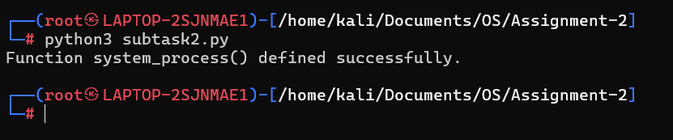

Sub-task3: Create at least two processes and start them concurrently.
Sol.-
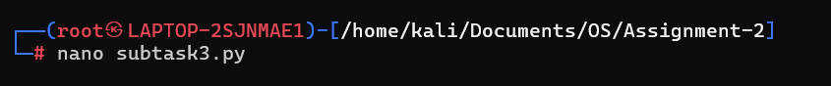
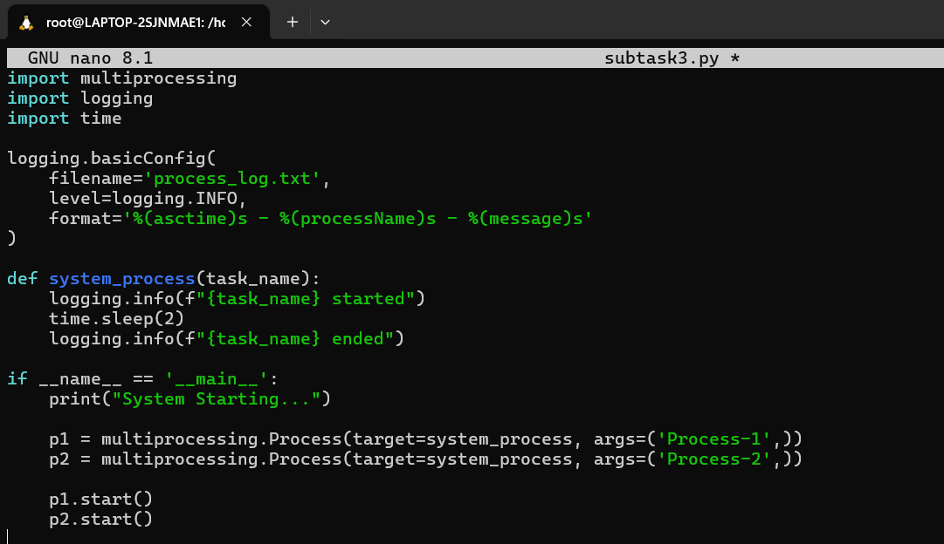
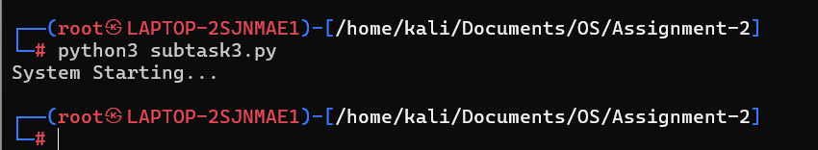

Sub-Task 4: Ensure proper termination and joining of processes, and verify the output in the log file.
Sol.-
